CAPTURING PACKETS

Name: Varshini Maskapuri

Department: OMIS

Course No.:660

Course Name: Business Data Networks & Cybersecurity

Title: Lab Project1: Wireshark Lab Getting Started

Lab No.:1

Date: 09-10-2025

**Lab Summary:**

In this lab, I learned how to use *Wireshark* to capture, filter, and analyze packets transmitted over a network. The primary focus was on observing the exchange of HTTP messages between a client and a server. Using Wireshark on macOS, I captured a simple web browsing session to ⁠ gaia.cs.umass.edu ⁠, filtered the packets to isolate HTTP traffic, and analyzed both the HTTP GET request and HTTP 200 OK response. This exercise demonstrated the layered structure of network communication (Frame → Ethernet → IP → TCP → HTTP) and how application-level details, such as browser type and request content, are encapsulated within transport and network protocols.

**Lab Objectives:**

* Install and run Wireshark on macOS.
* Capture live network traffic on the Wi-Fi interface.
* Filter packets to observe HTTP GET and HTTP 200 OK exchanges.
* Identify client and server IP addresses.
* Measure the time between a request and its reply.
* Determine browser information from the User-Agent header.
* Locate the destination port number used for HTTP traffic.

**Lab Implementation:**

**Browser homepage before capture**

This image shows the Safari browser opened on the homepage before any network activity for the lab. No Wireshark activity is occurring here yet.

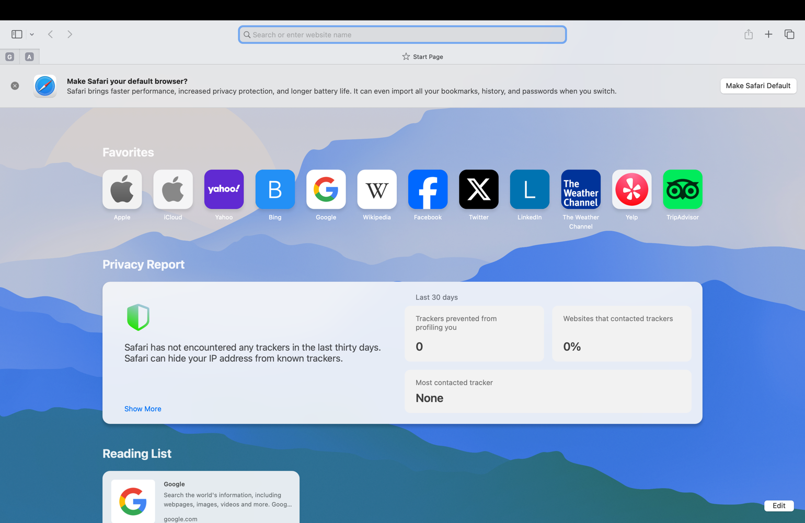

**Figure 1**

**Purpose:**

The lab instructions require generating network traffic to observe. By opening a browser, the user prepares to visit a specified URL (<http://gaia.cs.umass.edu/wireshark-labs/INTRO-wireshark-file1.html>)   
 Which will generate HTTP GET and HTTP OK messages for analysis

**Wireshark Startup Screen:**

This is the initial screen displayed upon launching Wireshark. It shows the available network interfaces for packet capture. In this case, the highlighted interface is Wi-Fi: en0, which is the primary interface for internet traffic on this Mac system. The graph beside each interface indicates real-time packet activity. To begin capturing, the Wi-Fi interface was selected.

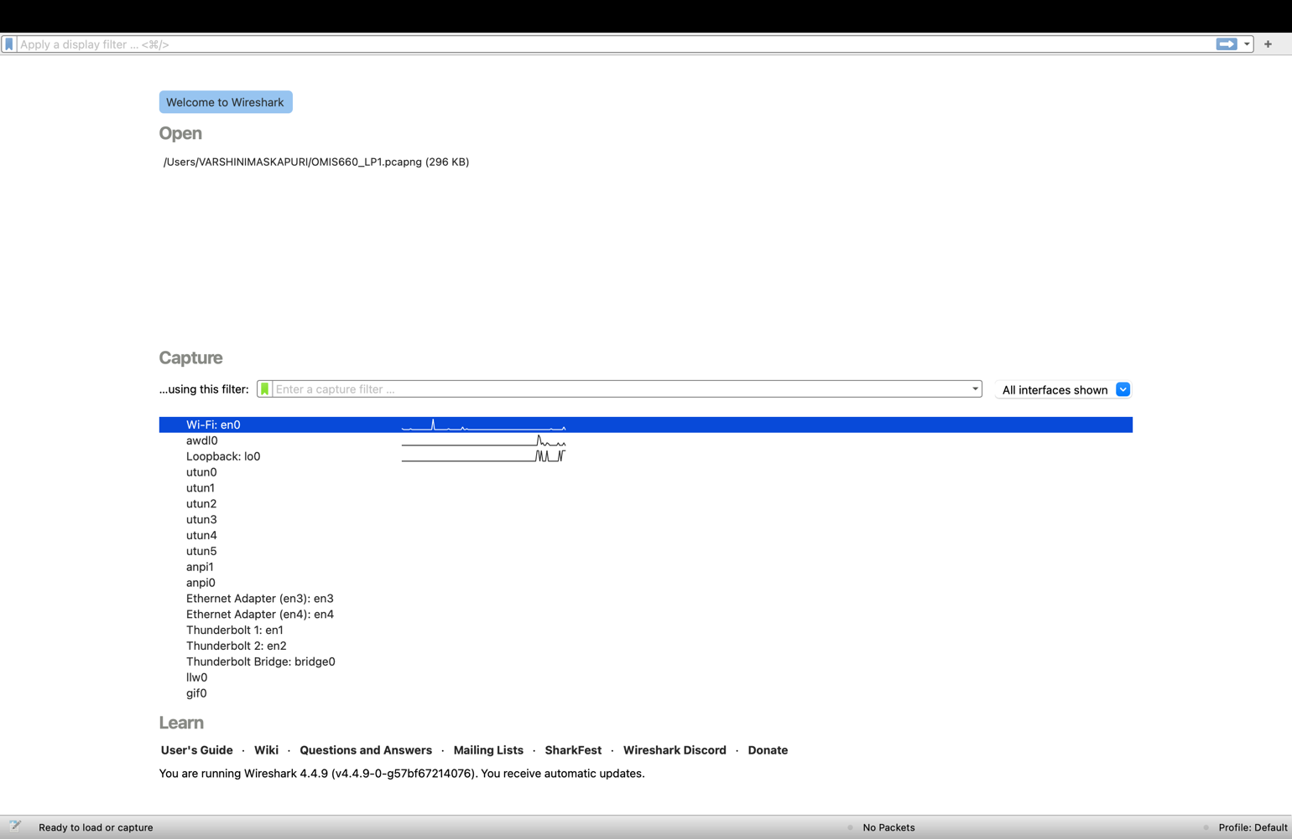

**Figure 2**

**Purpose**:

This step is critical because selecting the correct interface ensures that all relevant packets (HTTP, DNS, TCP, TLS) flowing through the active internet connection are captured

**Initial packet capture in wireshark:**

**Description:**

This screenshot shows Wireshark actively capturing packets from the Wi-Fi en0 interface. In the packet-listing pane, multiple TCP and TLSv1.2 packets are visible, indicating encrypted connections, acknowledgments (ACK), and retransmissions. The three-pane structure of Wireshark is clear:

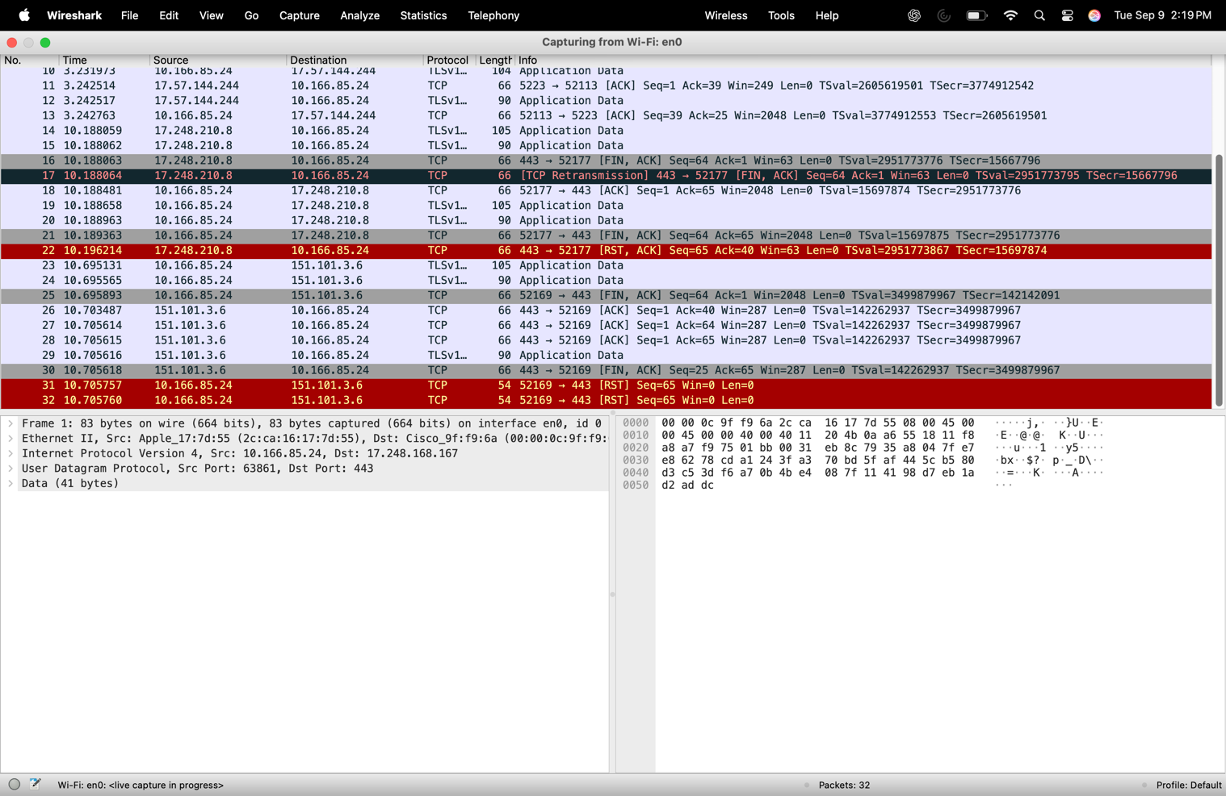

**Figure 3**

Top pane: Summary of each packet (protocol, source, destination, info).

Middle pane: Details of the highlighted packet, such as Ethernet II, IP, TCP.

Bottom pane: Hexadecimal and ASCII representation of packet contents.

**Purpose:**

This stage verifies that Wireshark is correctly capturing live traffic across various protocols.

**Download wireshark Labfile:**

**Description:**

The browser shows the gaia.cs.umass.edu webpage with the congratulatory message: “Congratulations! You’ve downloaded the first Wireshark lab file!”

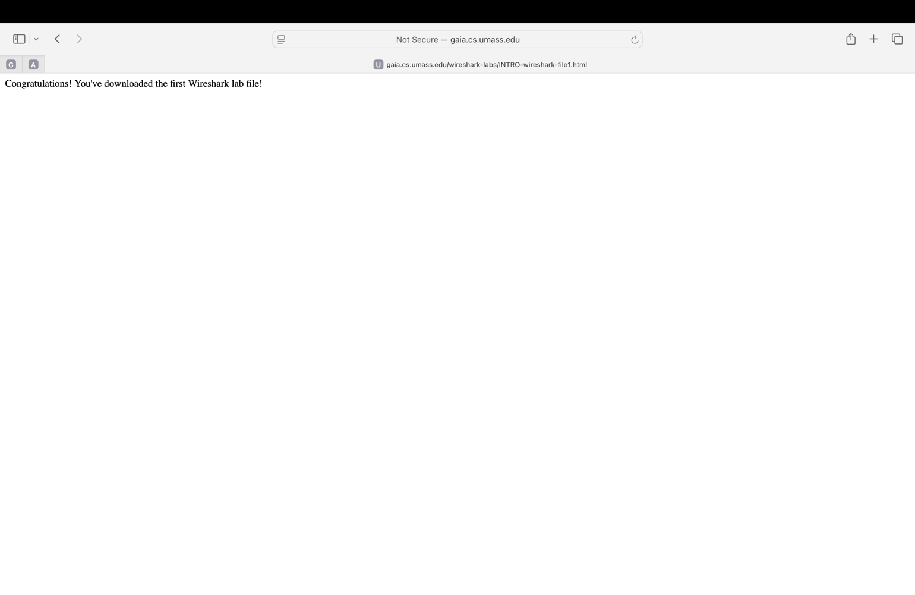

**Figure 4**

**Purpose:**

This confirms that the HTTP GET request successfully retrieved the HTML file from the server. The packet capture during this exchange will include the HTTP GET request and the HTTP OK (200) reply

**Wireshark capture after download:**

**Description:**

This capture shows a sequence of packets including DNS, TCP, and TLSv1.2, along with HTTP traffic directed to gaia.cs.umass.edu. The DNS queries are responsible for resolving the hostname gaia.cs.umass.edu into its corresponding IP address (128.119.245.12). Once resolution is complete, a TCP three-way handshake (SYN, SYN/ACK, ACK) is initiated between the client and server to establish a connection. Following this, TLSv1.2 packets indicate the setup of a secure session, and HTTP packets (GET and OK) confirm the actual web page request and server response. The highlighted packet in this capture is part of the TCP handshake (SYN/ACK), which plays a critical role in connection establishment.

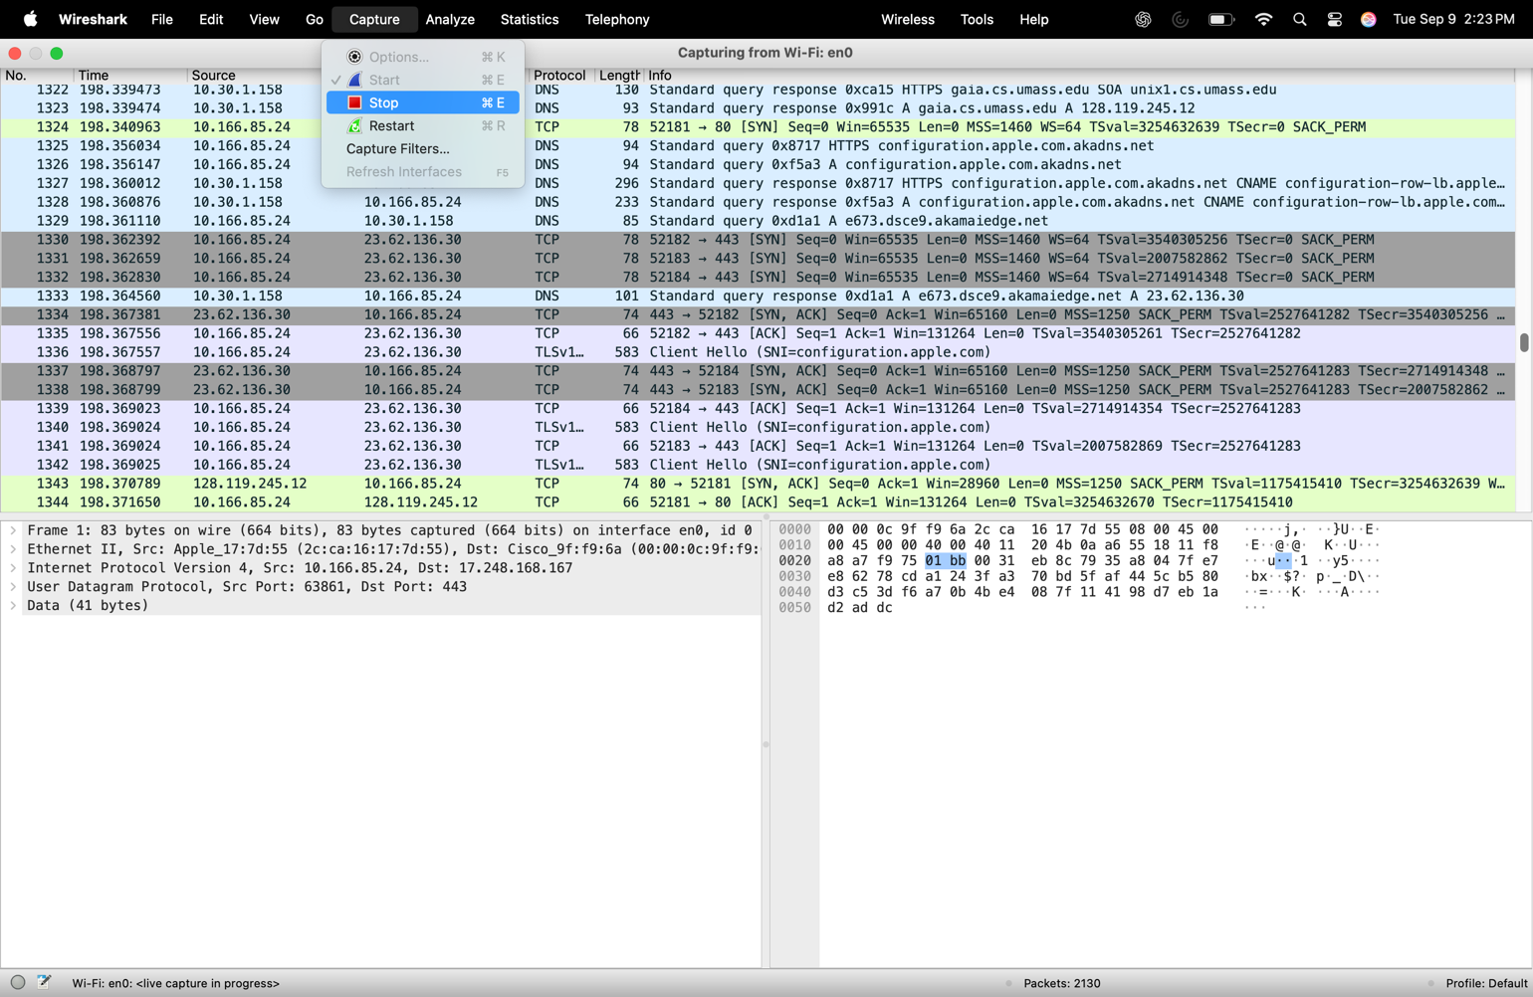



**Figure 5**

**Purpose:**

This stage demonstrates the full communication sequence — starting from DNS resolution, progressing through the TCP handshake, and culminating in the HTTP GET/200 OK exchange. At this point, the objective of the lab activity is complete because the requested page was successfully retrieved from the server.

**Note:**

The capture process ends here, as the required HTTP GET and HTTP OK packets have been recorded and analyzed, satisfying the lab’s task of observing a complete client–server transaction.

**Filtering for HTTP packets:**

**Description:**

Here the http display filter has been applied in Wireshark. The filtered packets clearly show the HTTP protocol messages, including:



GET /wireshark-labs/INTRO-wireshark-file1.html



HTTP/1.1 200 OK response

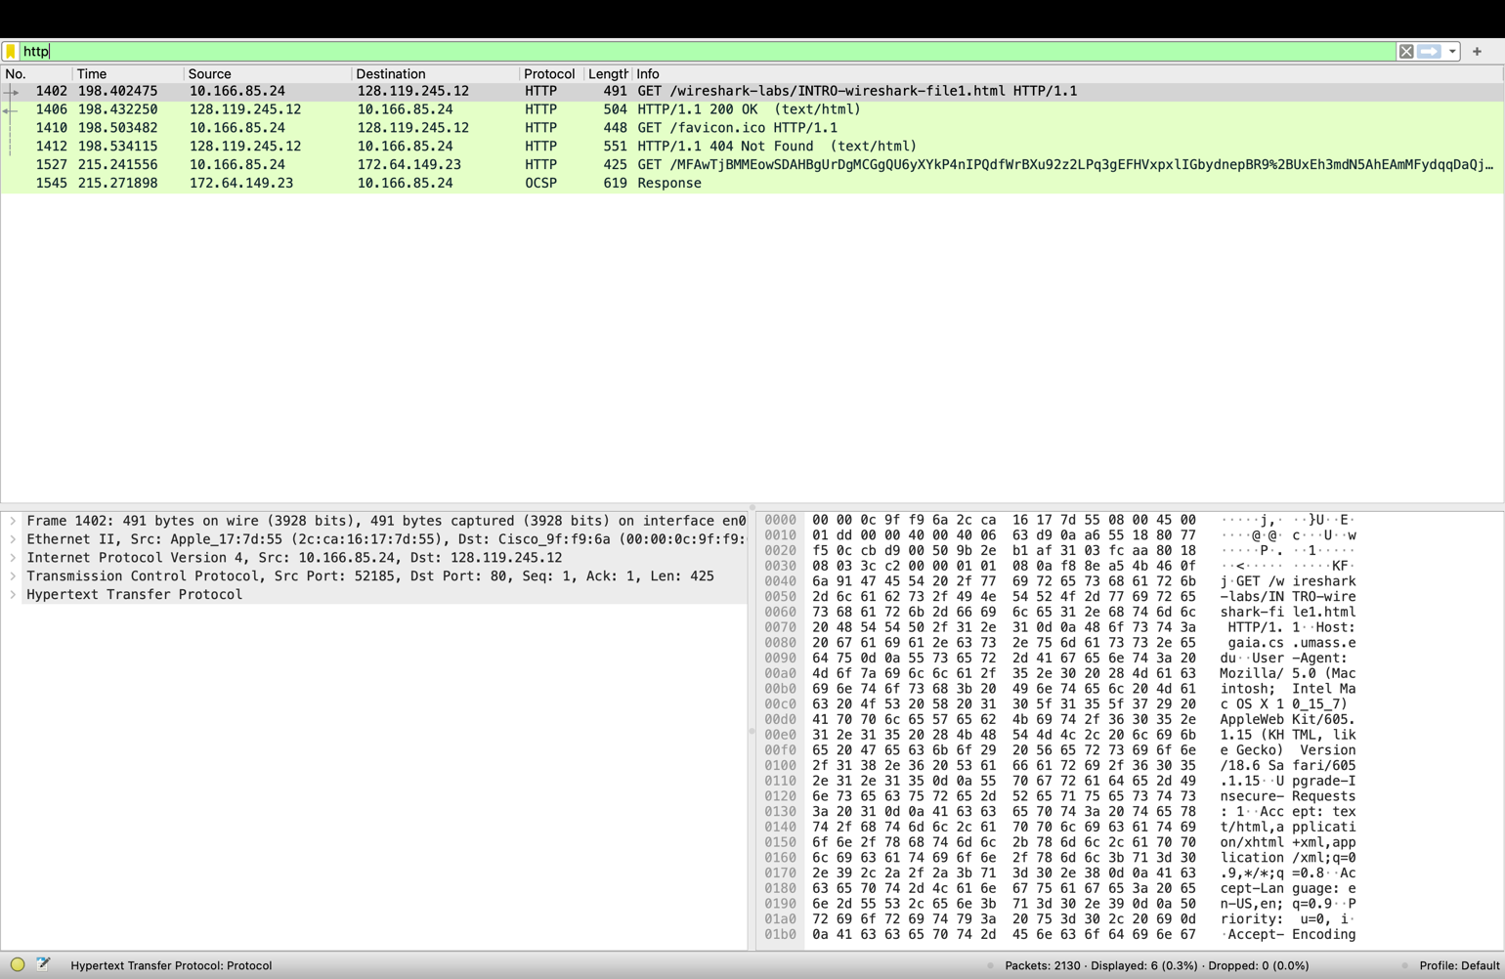



**Figure 6**

**Purpose:**

This isolates relevant packets from the capture, making it easier to analyze the HTTP request/response process and measure timing between them.

**Expanded HTTP GET packet details:**

**Description:**

This screenshot zooms into the HTTP GET request. The middle pane shows protocol headers at each layer:

* Ethernet II (hardware-level info)
* IPv4 (source and destination addresses)
* TCP (source/destination ports)
* HTTP (method = GET, Host = gaia.cs.umass.edu, User-Agent = Safari browser)

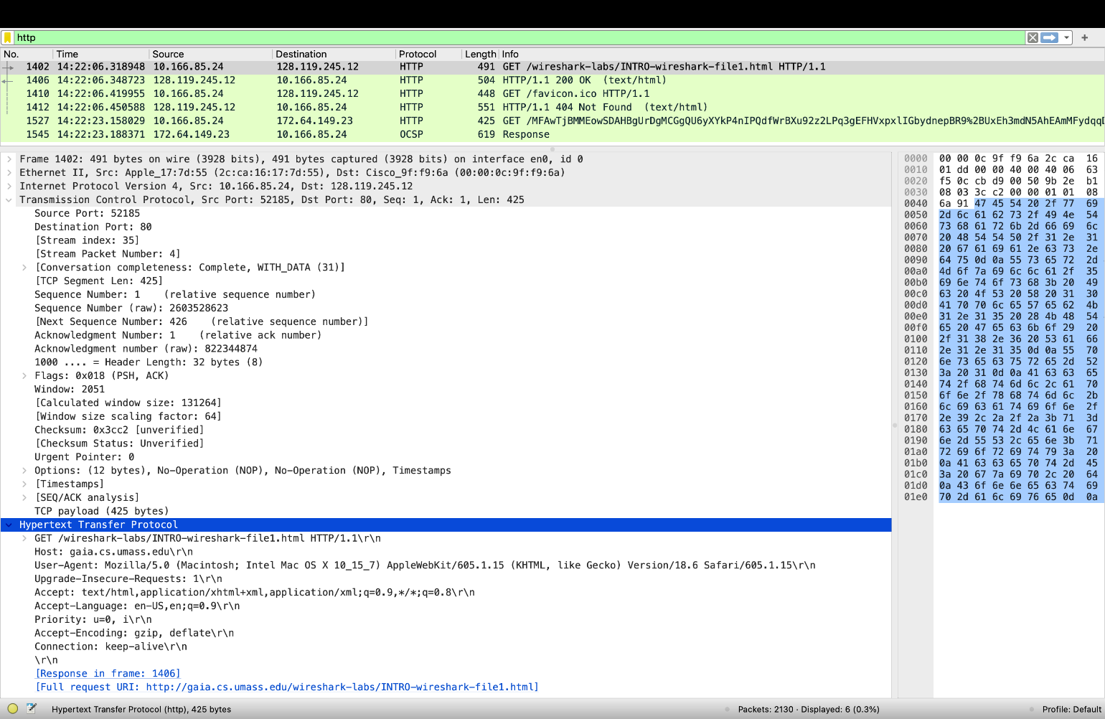



**Figure 7**

**Purpose:**

It provides details for answering lab questions such as:

* What browser was used? → Safari (from User-Agent field)
* What is the destination port? → Port 80 (standard for HTTP)

**TCP Packet Inspection:**

**Description**

This image focuses on TCP packets associated with the HTTP transaction. It shows sequence numbers, acknowledgments, and flags (SYN, ACK, FIN, RST). One of the highlighted packets displays a RST (reset), which terminates a TCP session.

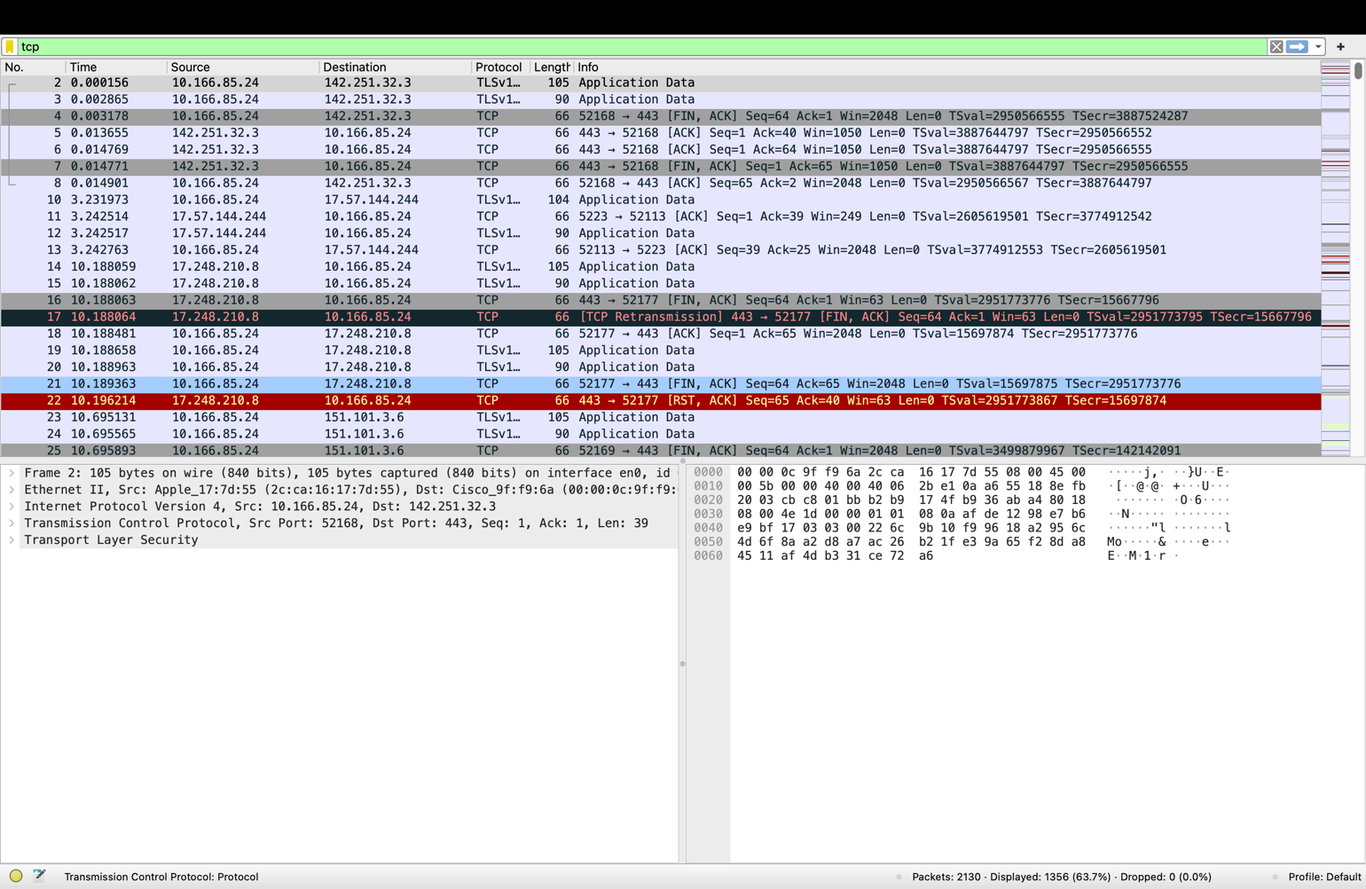

**Figure 8**

**Purpose:**

It highlights how Wireshark can be used to examine the reliability mechanisms of TCP, including session establishment (SYN, SYN-ACK, ACK) and session termination (FIN/RST)

**QUIC Packet:**

**Description:**

This capture displays packets using the QUIC protocol between your computer (10.166.85.24) and a remote server (172.253.132.84). The packets include Initial, Handshake, and Protected Payloads, which are part of QUIC’s secure session setup. Each QUIC exchange replaces the traditional TCP + TLS handshake by integrating transport and security in a single layer.

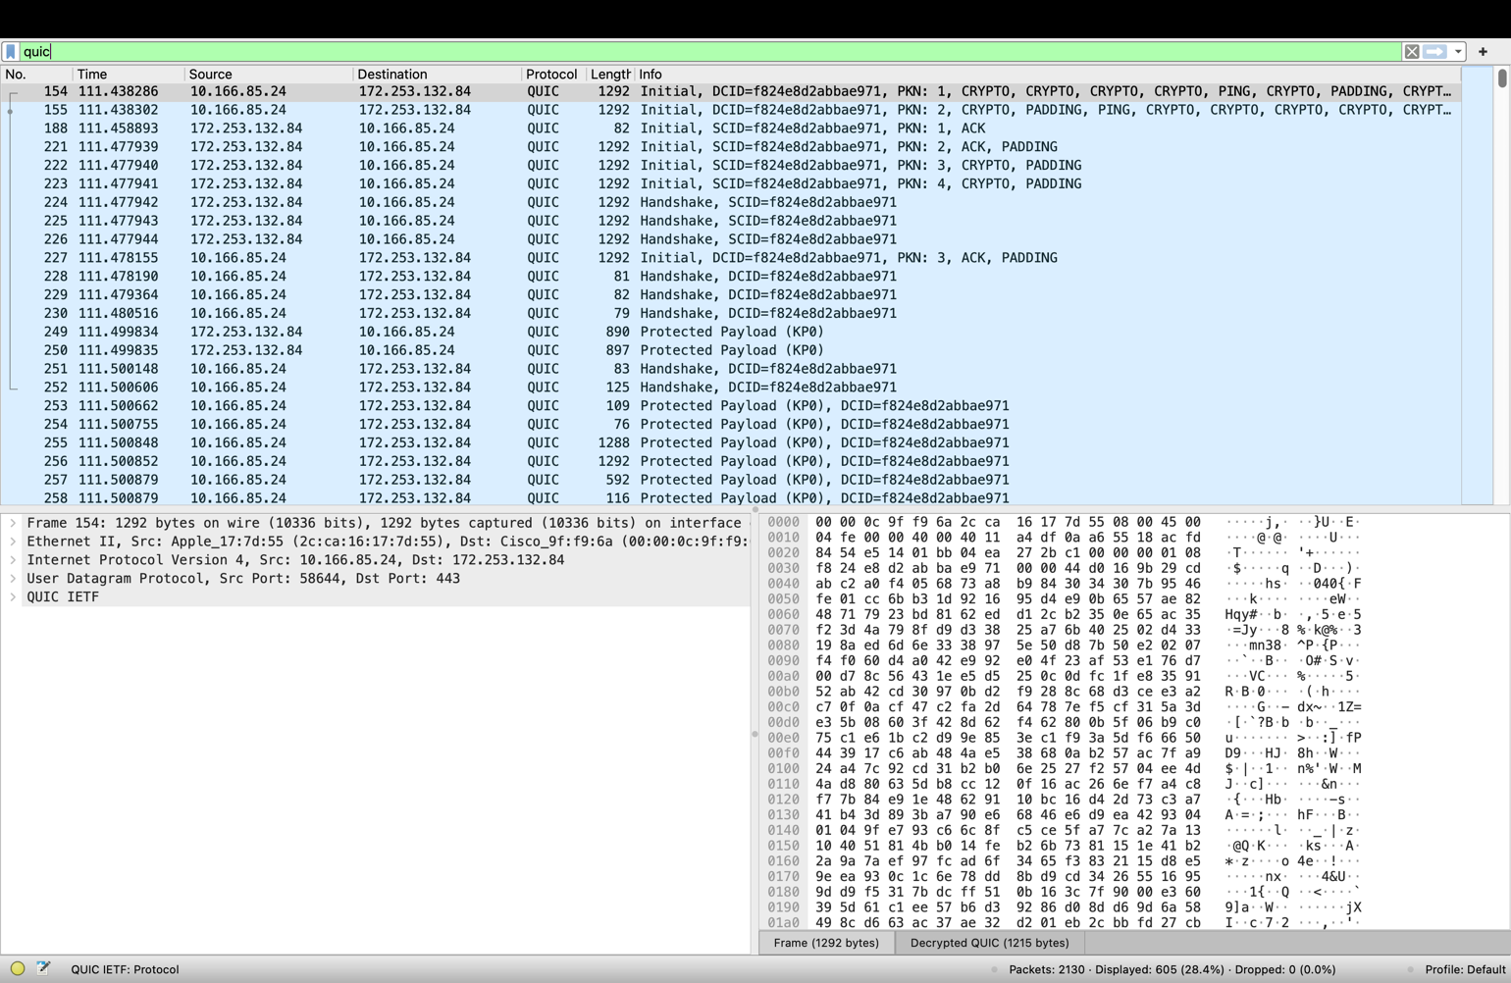



**Figure 9**

**Purpose:**

This demonstrates that modern applications (such as Google services) use QUIC over UDP for faster, encrypted communication. It highlights how Wireshark can capture and decode emerging transport protocols beyond TCP.

**DNS Packets:**

**Description:**

This screenshot shows DNS query and response packets. Queries are made by the client (10.166.85.24) to resolve hostnames such as gaia.cs.umass.edu and Google services (accounts.google.com, clients4.google.com). The responses provide the corresponding IP addresses.

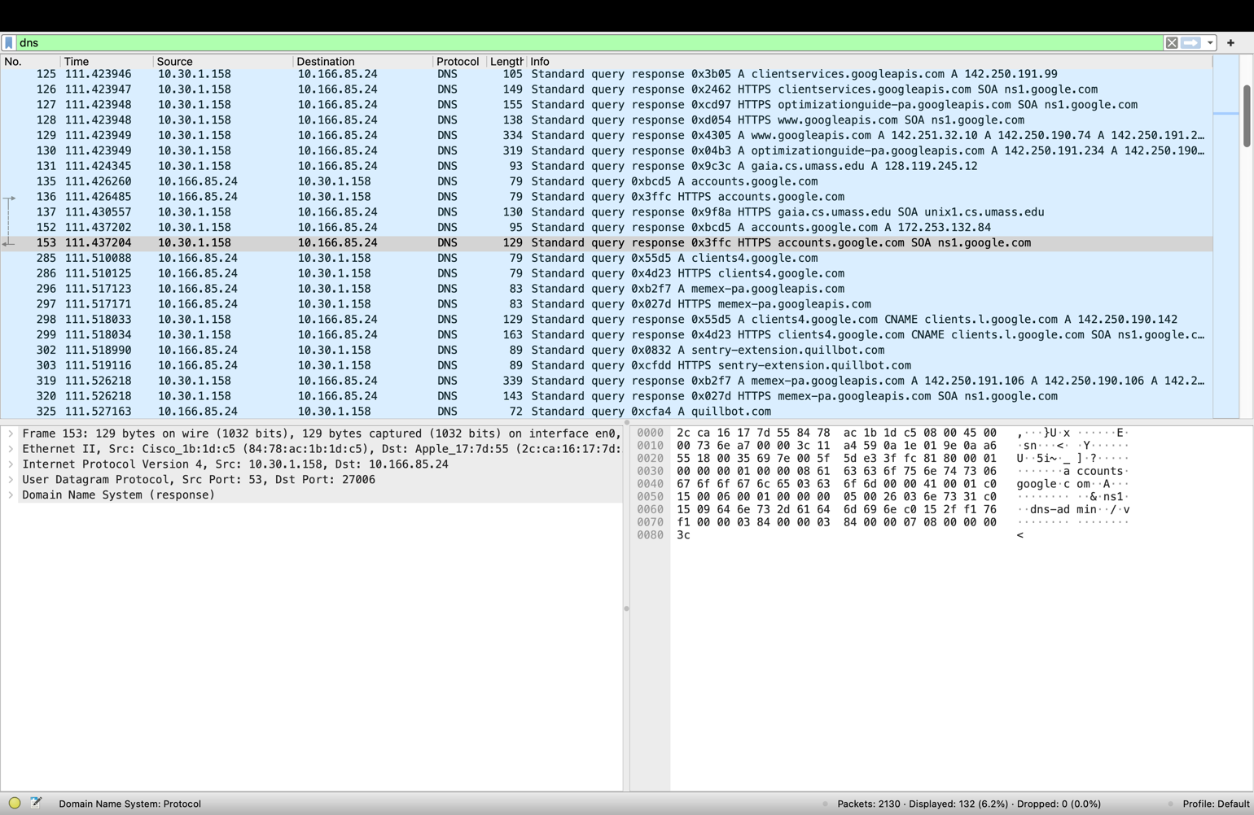



**Figure 10**

**Purpose:**

This illustrates the role of DNS in mapping domain names to IP addresses before HTTP or QUIC sessions can be established. Without DNS, the client would not know the server’s IP to initiate communication.

**UDP Packets:**

**Description:**

This capture shows UDP traffic exchanged between the client and various servers. UDP is also used for DNS queries (port 53) and may carry QUIC traffic. Unlike TCP, UDP does not require a handshake or acknowledgment.

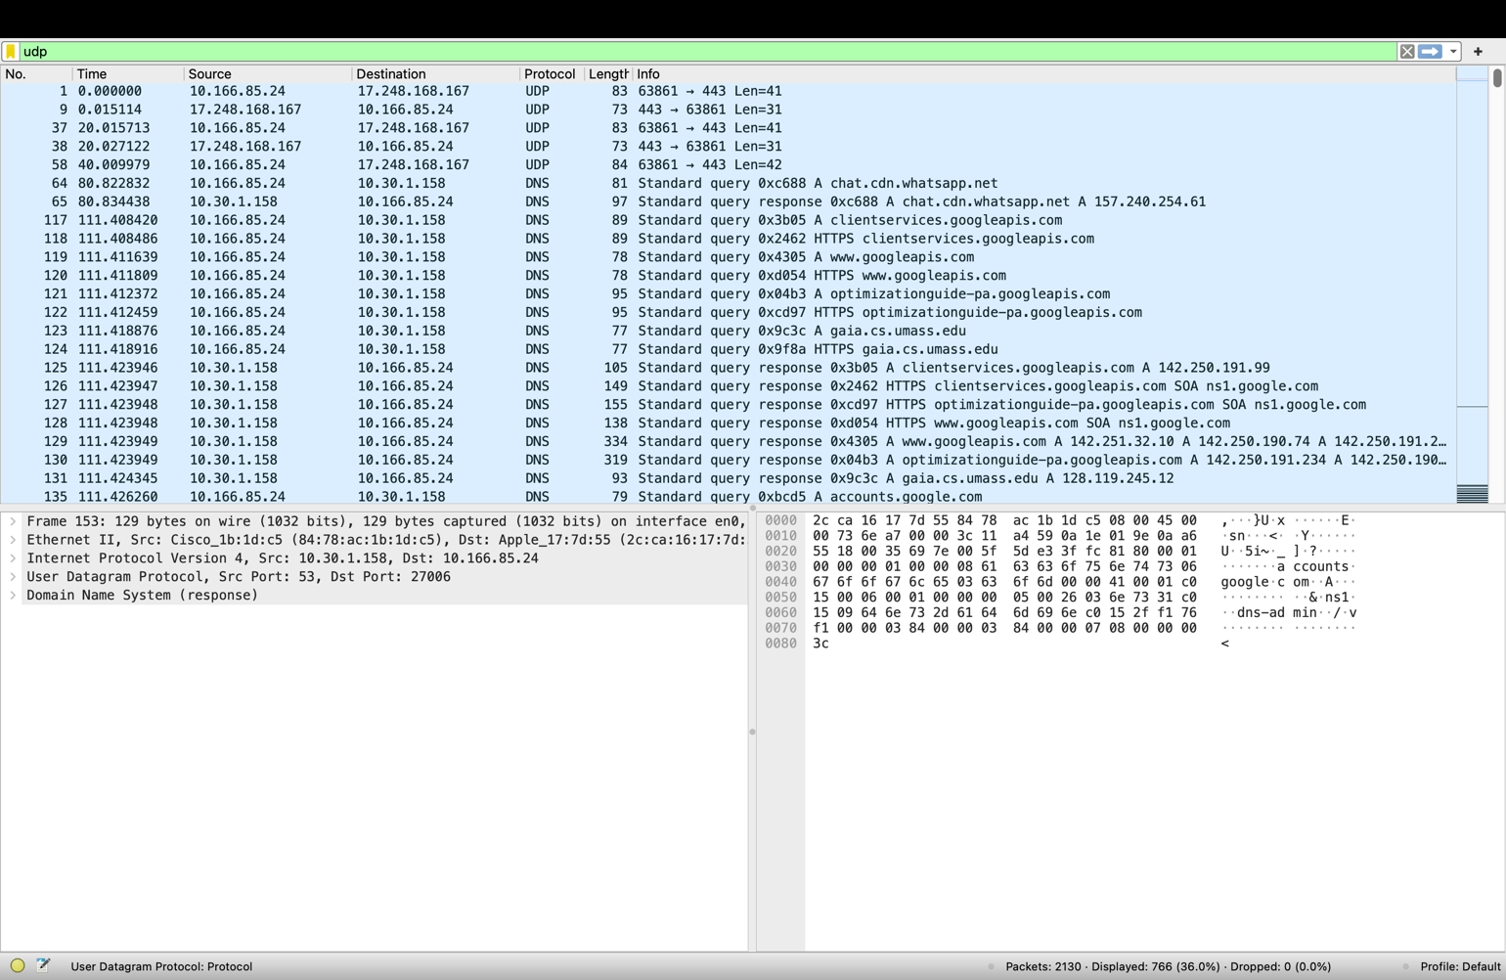



**Figure 11**

**Purpose:**

It highlights how UDP underlies many higher-level protocols (DNS, QUIC). It also contrasts with TCP’s reliability mechanisms, reinforcing why labs often analyze both.

**TLS Packets:**

**Description:**

This screenshot shows TLSv1.2 packets, including Client Hello and Server Hello messages. These are essential for establishing encrypted HTTPS sessions over TCP.

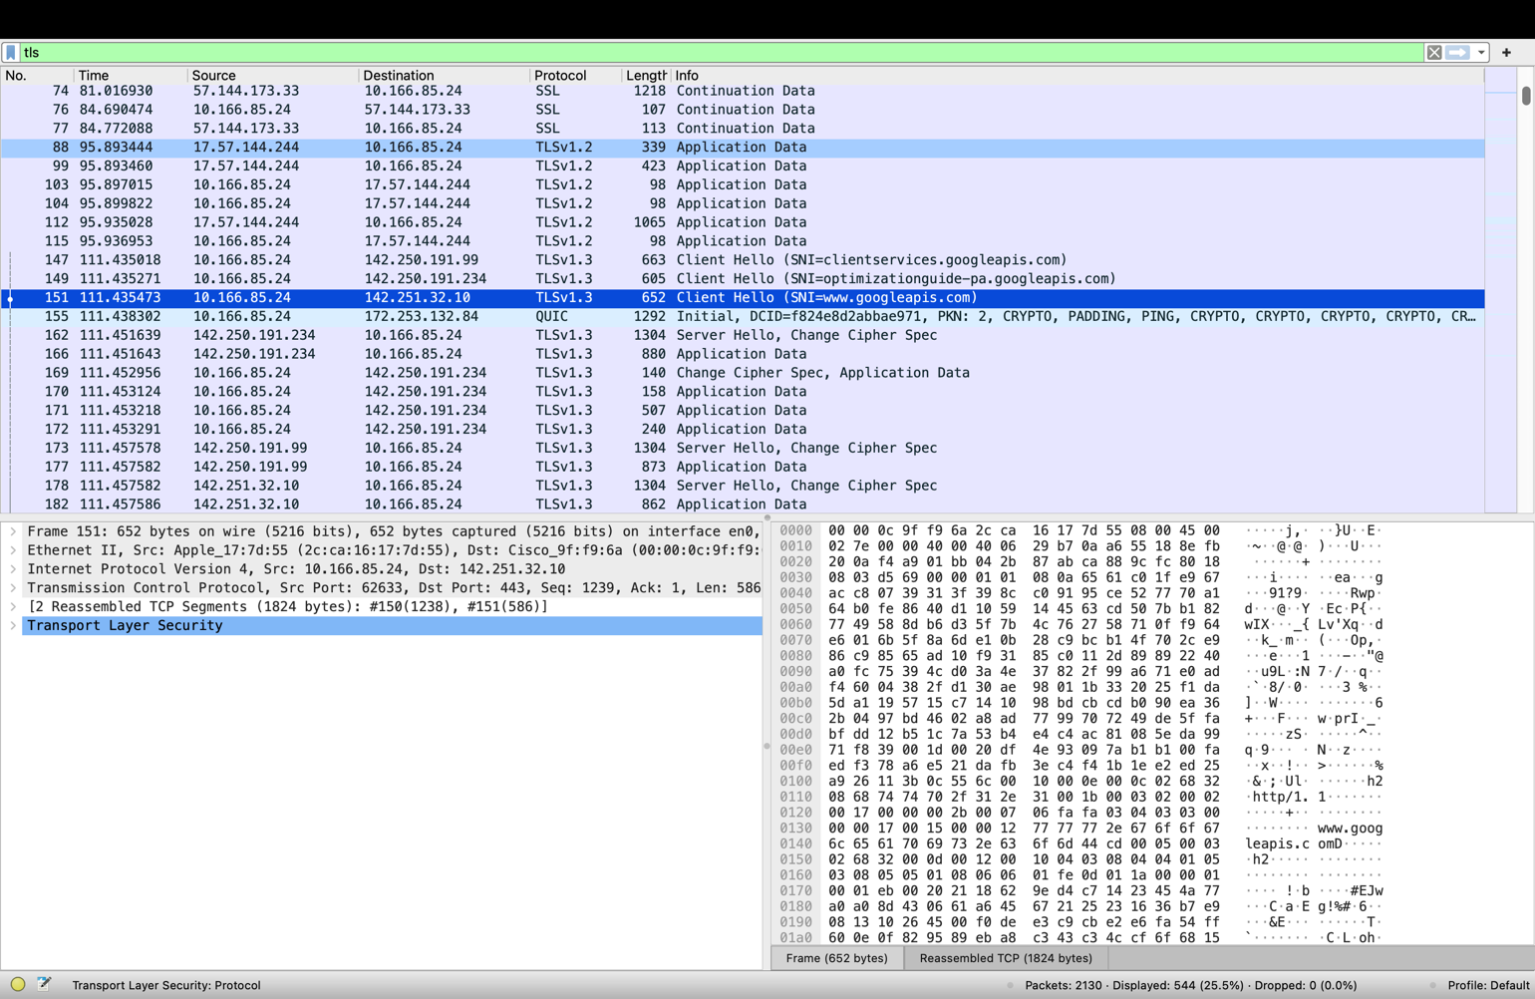



**Figure 12**

**Purpose:**

It demonstrates how web traffic is secured through TLS negotiation. By analyzing these packets, students learn how browsers and servers agree on encryption protocols before exchanging sensitive data.

**HTTP GET Request:**

**Description:**

This capture highlights the HTTP GET request for the file /wireshark-labs/INTRO-wireshark-file1.html sent from the client (10.166.85.24) to the server (128.119.245.12). The details pane shows HTTP headers including the Host (gaia.cs.umass.edu) and User-Agent (Safari browser).

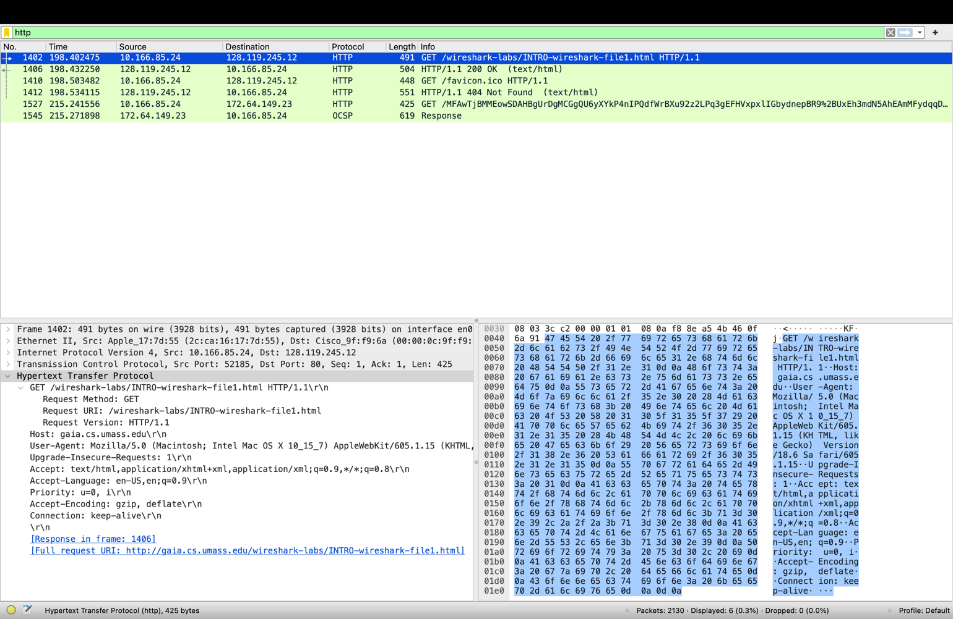



**Figure 13**

**Purpose:**

This step is central to the lab, as it shows the client actively requesting the lab HTML file. It provides the basis for analyzing web browser communication with servers.

**HTTP 200 OK Response:**

**Description:**

This screenshot shows the HTTP/1.1 200 OK response from the server (128.119.245.12) to the client. It indicates that the request was successful and that the requested HTML file was delivered.

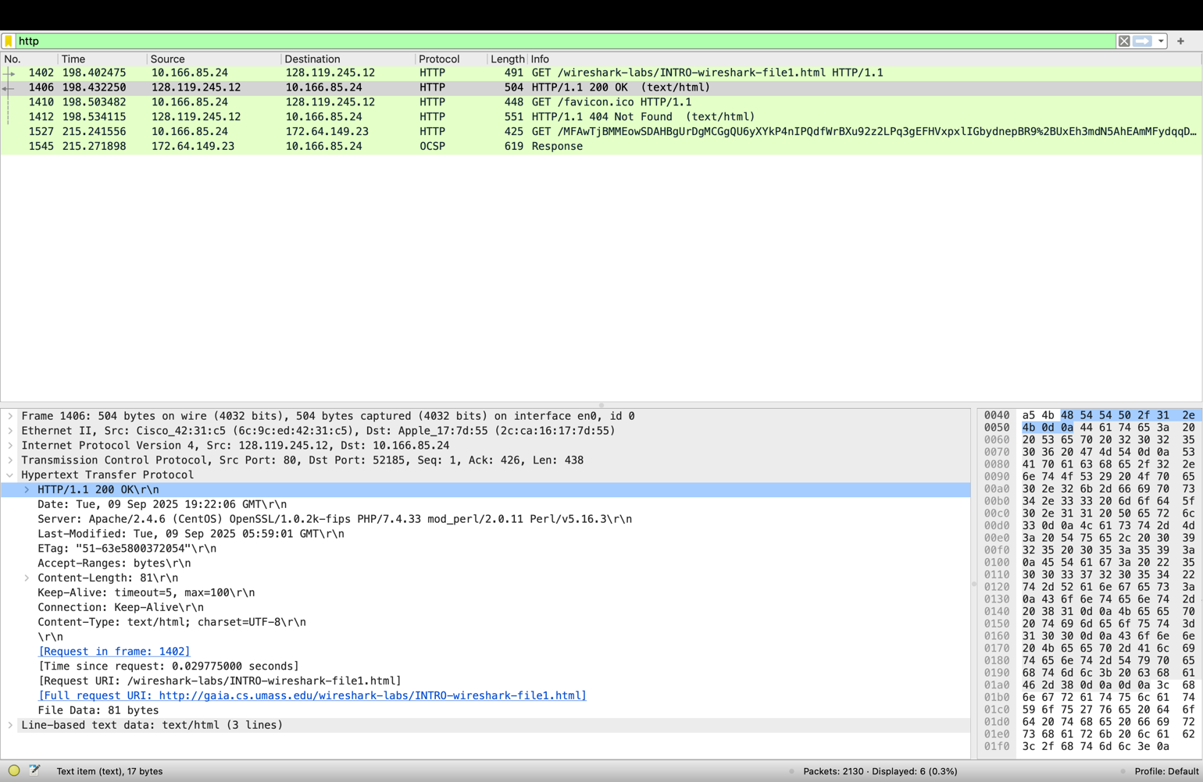

**Figure 14**

**Purpose:**

It confirms that the web transaction completed successfully and allows measurement of response time between the GET request and the OK message (≈ 0.03 seconds in your case).

**QUESTIONS:**

**1.**⁠ ⁠Which of the following protocols are shown as appearing (i.e., are listed in the Wireshark “protocol” column) in your trace file: TCP, QUIC, HTTP, DNS, UDP, TLSv1.2?

**A:** The packet trace revealed the presence of several key protocols. These included *TCP* (used for connection establishment and reliable transmission), *HTTP* (responsible for web requests and responses), *DNS* (used for hostname resolution), *TLSv1.2* (providing encryption for secure sessions), *UDP* (supporting connectionless communication such as DNS queries), and *QUIC* (observed in traffic to Google services).

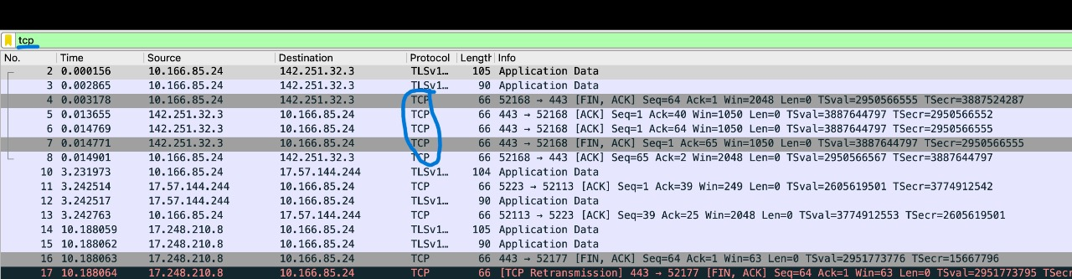

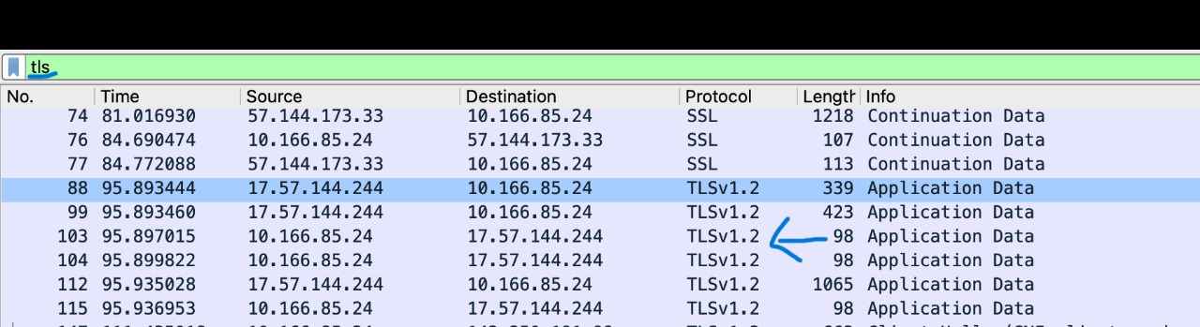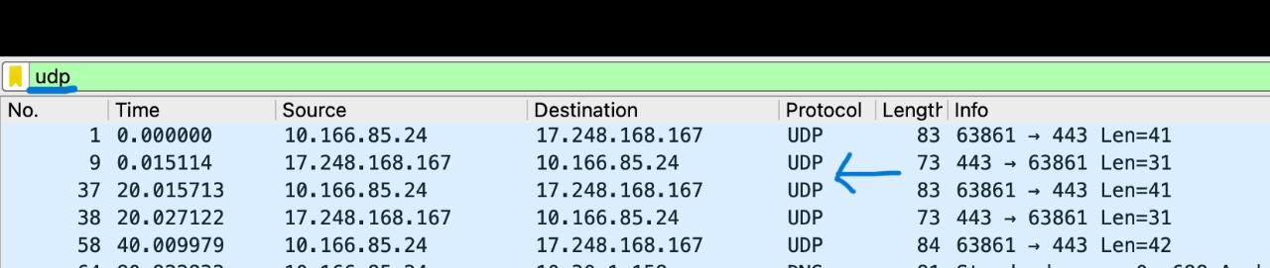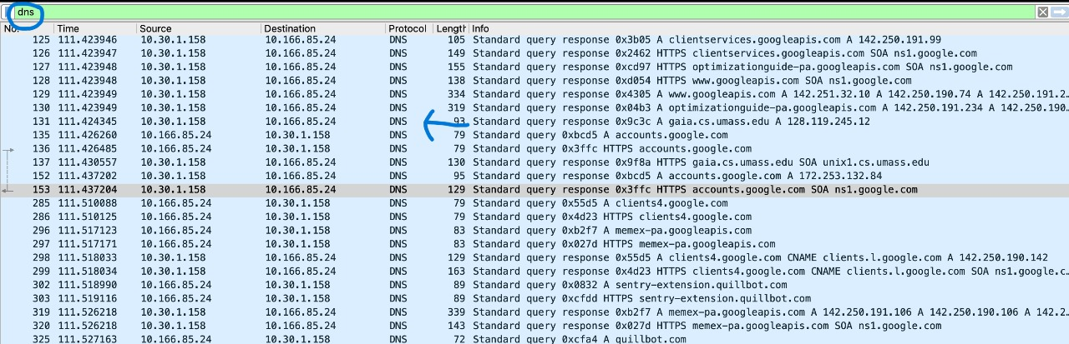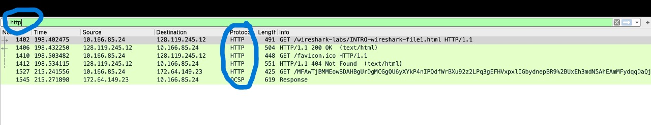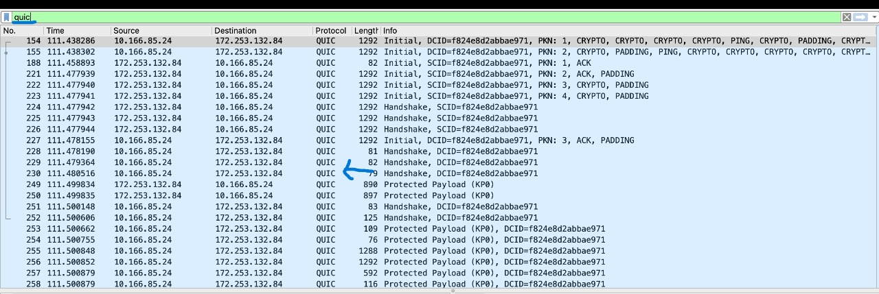

**2.⁠ ⁠**How long did it take from when the HTTP GET message was sent until the HTTP OK reply was received? (By default, the value of the Time column in the packet-listing window is the amount of time, in seconds, since Wireshark tracing began. (If you want to display the Time field in time-of-day format, select the Wireshark View pull down menu, then select Time Display Format, then select Time-of-day.)

**A:** In the trace file, the HTTP GET request was recorded at timestamp 14:22:06.318948 (Packet 1402). The corresponding HTTP 200 OK response was recorded shortly afterward at timestamp 14:22:06.348723 (Packet 1406). By subtracting the two values, the elapsed time between the request and the response is calculated as 0.0298 seconds (approximately 30 milliseconds).

This result represents the round-trip time for the client’s HTTP request to reach the server and for the server’s acknowledgment to return, illustrating the efficiency of the communication in this capture.

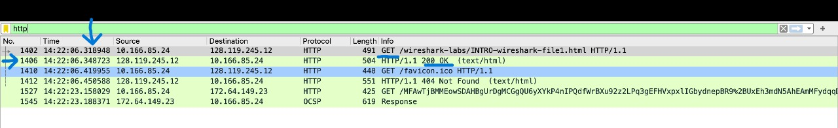

**3.⁠** ⁠What is the Internet address of the gaia.cs.umass.edu (also known as www-net.cs.umass.edu)? What is the Internet address of your computer or (if you are using the trace file) the computer that sent the HTTP GET message?

To answer the following two questions, you’ll need to select the TCP packet containing the HTTP GET request (hint: this is packet number 286). The purpose of these next two questions is to familiarize you with using Wireshark’s “Details of selected packet window”; see Figure 3. To do this, click on Packet 286 (your screen should look similar to Figure 3). To answer the first question below, then look in the “Details of selected packet” window toggle the triangle for HTTP (your screen should then look similar to Figure 5); for the second question below, you’ll need to expand the information on the Transmission Control Protocol (TCP) part of this packet.

**A:** From the HTTP GET packet details, the *destination IP address* of the server gaia.cs.umass.edu was identified as *128.119.245.12, while the **source IP address* of the client system initiating the request was *10.166.85.24*. This confirms the direct communication path between the client and the target web server.

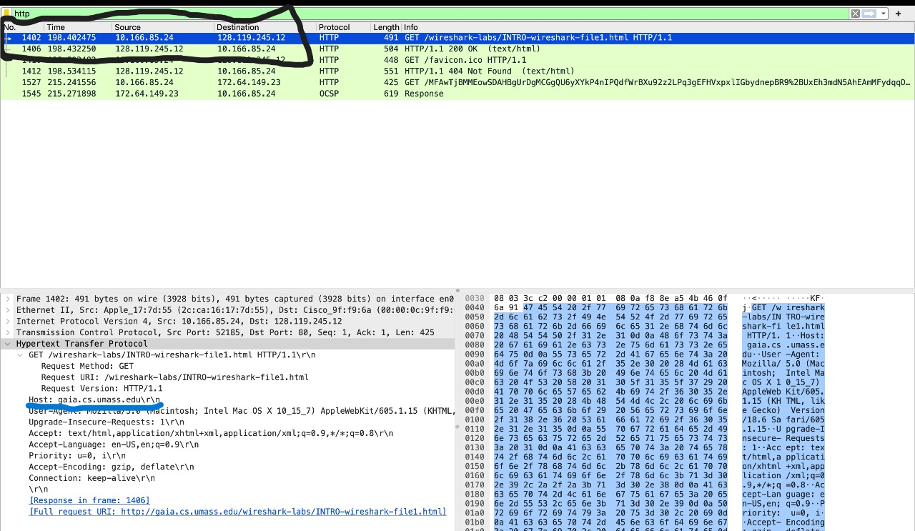

**4.⁠** ⁠Expand the information on the HTTP message in the Wireshark “Details of selected packet” window (see Figure 3 above) so you can see the fields in the HTTP GET request message. What type of Web browser issued the HTTP request? The answer is shown at the right end of the information following the “User-Agent:” field in the expanded HTTP message display. [This field value in the HTTP message is how a web server learns what type of browser you are using.]

•⁠ ⁠Firefox, Safari, Microsoft Internet Edge, Other

**A:** Inspection of the *User-Agent field* in the HTTP GET request revealed the following string:

1. Mozilla/5.0 (Macintosh; Intel Mac OS X 10_15_7) AppleWebKit/605.1.15

(KHTML, like Gecko) Version/16.6 Safari/605.1.15

1. The inclusion of Safari/605.1.15 clearly indicates that the request was issued using the *Safari web browser* on macOS.

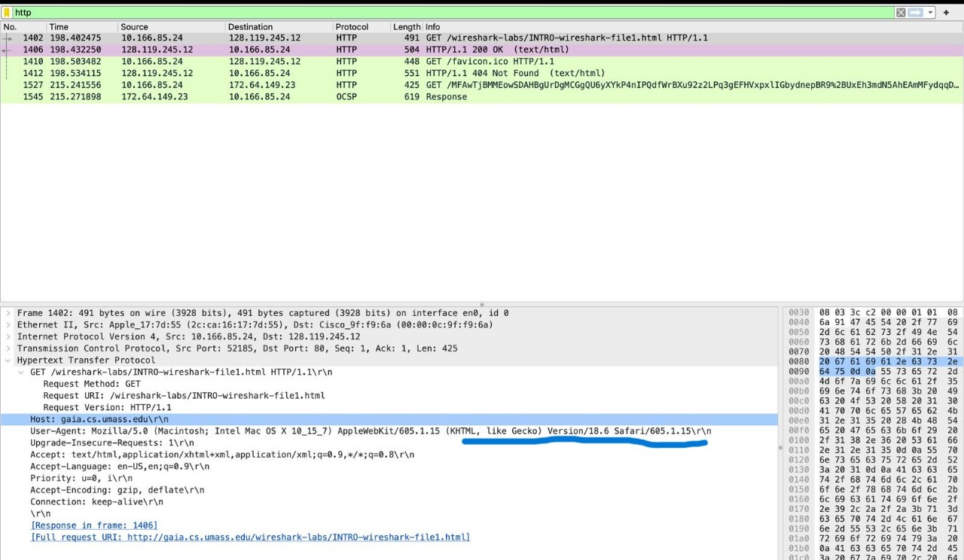

**5.⁠** ⁠Expand the information on the Transmission Control Protocol for this packet in the Wireshark “Details of selected packet” window (see Figure 3 in the lab writeup) so you can see the fields in the TCP segment carrying the HTTP message. What is the destination port number (the number following “Dest Port:” for the TCP segment containing the HTTP request) to which this HTTP request is being sent?

**A:** The TCP header information for the segment containing the HTTP GET request lists the *Destination Port* as *80*, which is the standard port number for HTTP traffic. This confirms that the client’s web request was sent using the default HTTP service port.

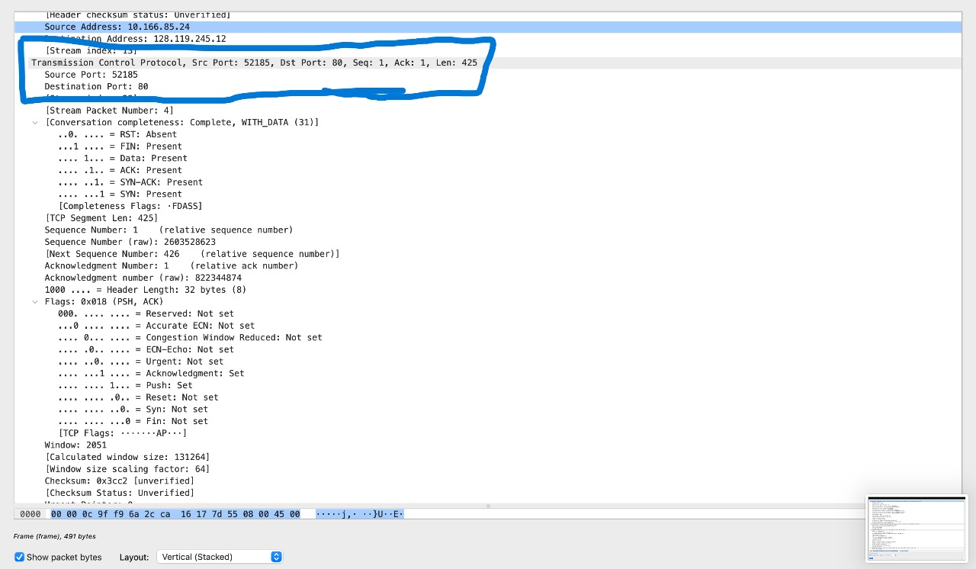

**6.** Provide screenshots of the HTTP GET and HTTP OK messages.

**A:** Two key packets were identified and captured for documentation:

•⁠ ⁠The *HTTP GET request (Packet 1402), which contains the request line ⁠ GET /Wireshark-labs/INTRO-wireshark-file1.html ⁠ along with headers such as *Host and User-Agent.

•⁠ ⁠The *HTTP 200 OK response (Packet 1406)*, which confirms successful retrieval of the requested file and marks the completion of the transaction.

These screenshots illustrate the full client–server interaction sequence for a basic HTTP exchange.

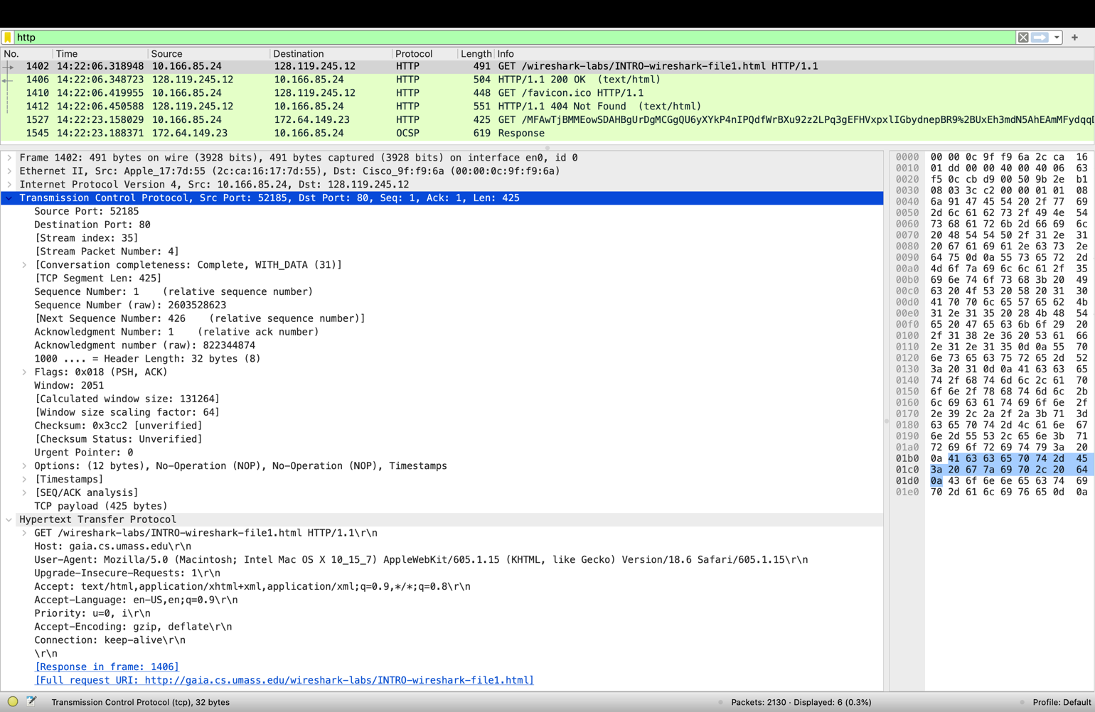



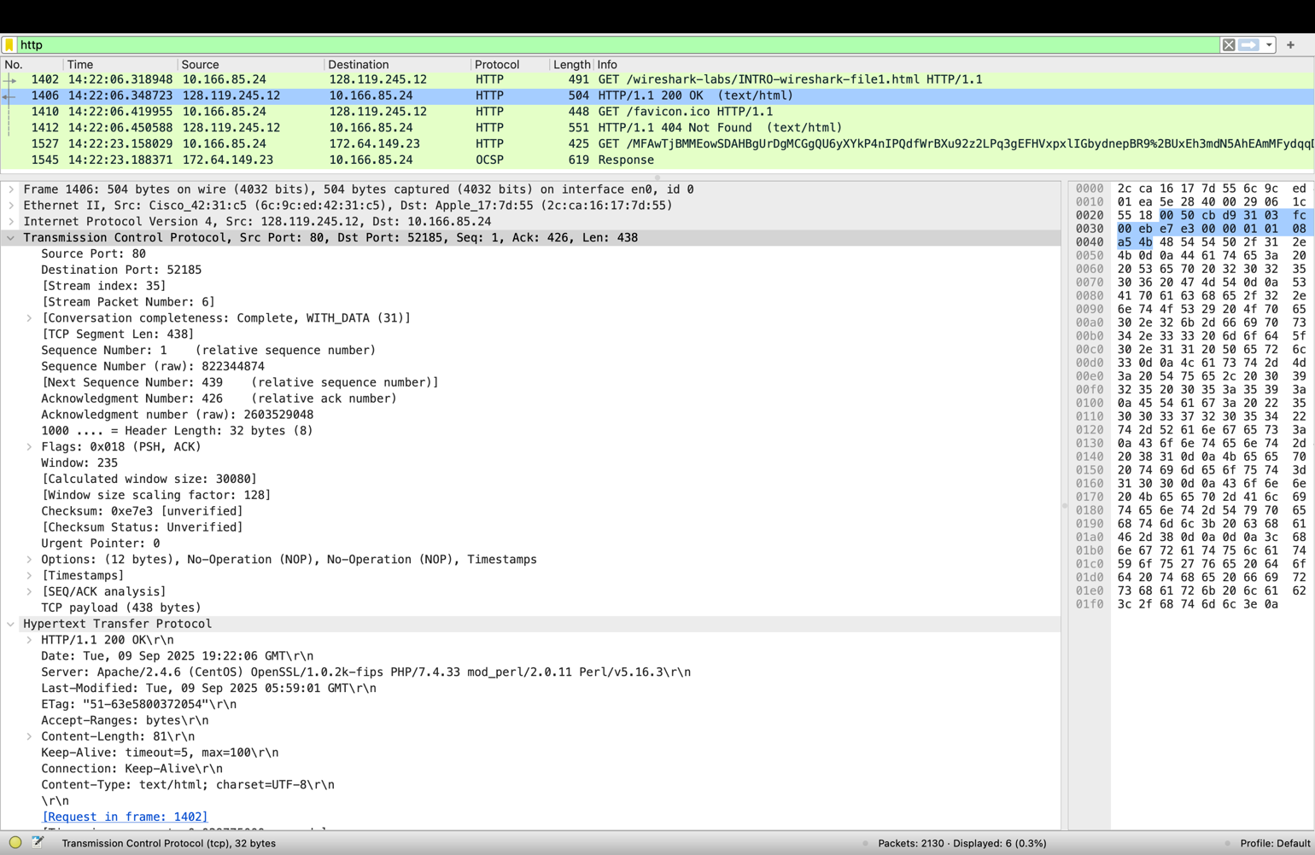



**CONCLUSION:**

This lab offered practical exposure to network analysis with Wireshark, bridging theoretical concepts of the TCP/IP stack with real-time packet inspection. Through the capture and study of DNS queries, TCP handshakes, TLS sessions, QUIC traffic, and HTTP exchanges, the layered design of Internet communication was effectively illustrated. The analysis enabled accurate identification of client and server IPs, verification of browser type and port usage, and calculation of HTTP response time. Ultimately, the exercise emphasized the effectiveness of modern networking protocols and showcased Wireshark as an essential tool for exploring and understanding network operations in practice.